MOBILE APPLICATIONS MINI STUDENT APP
Student Name: FAITH WANJA
Admission Number: BIT/2024/74102
Unit: Mobile Application Development (BIT 4107)
WEEK 1: INTRODUCTION TO MOBILE DEVELOPMENT
Objective:
To install and configure the Flutter development environment and create the first Flutter application.

1.1Activities Completed:
- Installed Flutter SDK and Android Studio.
- Configured Android SDK and Flutter SDK.
3. Set up and launched the Pixel 6 emulator.
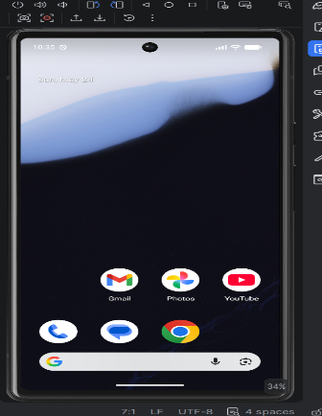
4. Explored the Flutter project structure and main.dart.
5. Ran the default Flutter counter application.

1.2 Challenges Faced:
• Flutter SDK detection issues.
• Emulator startup problems.

1.3 Solutions Implemented:
• Correctly configured SDK paths.
• Recreated and restarted the emulator.

1.4 Reflection:
I learned the Flutter development workflow, project structure, and application execution process.

WEEK 2: PROGRAMMING LANGUAGES AND FRAMEWORKS
Objective:
To learn Flutter programming concepts and build the user interface of a Student Management Application.
Activities Completed:
- Created hello world mobile app. Changed colors, added button, ran on emulator.
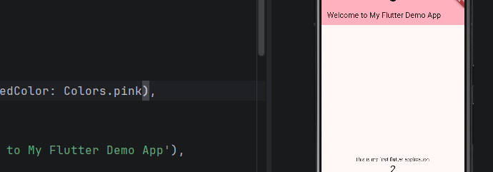
• Studied:
Variables
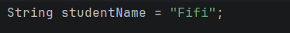
functions, loops, and classes
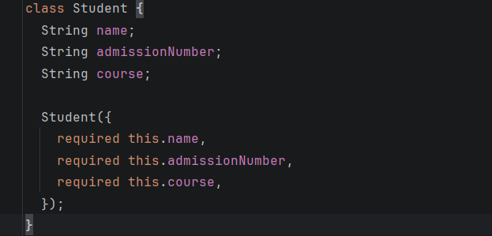

Wireframes and mockups

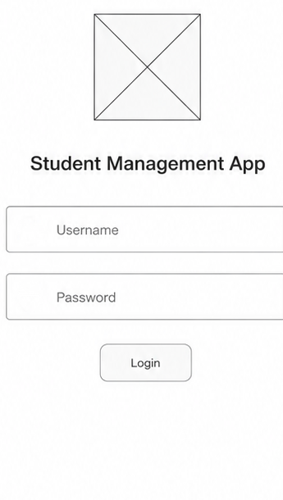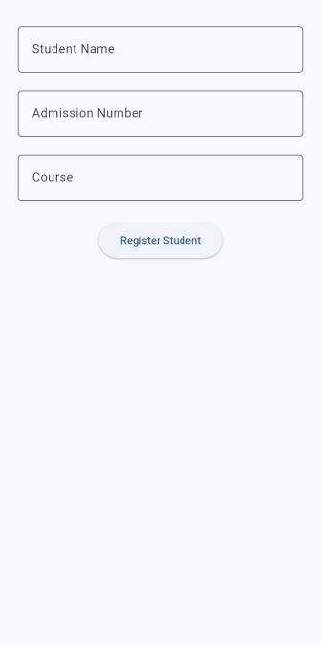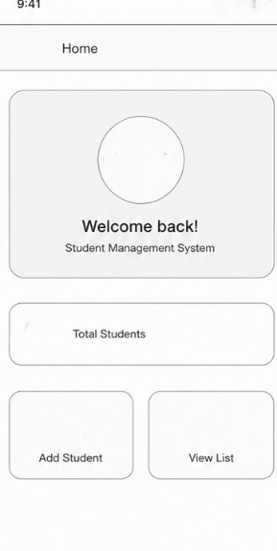

Student management app setup
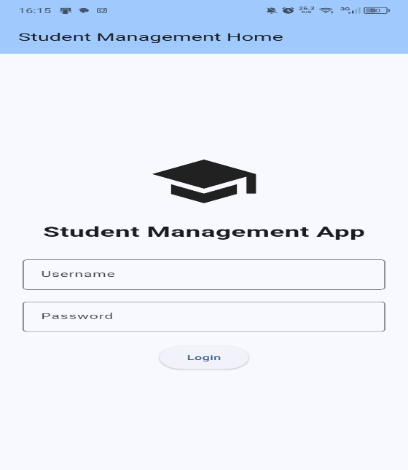
• Developed Student Registration Screen.
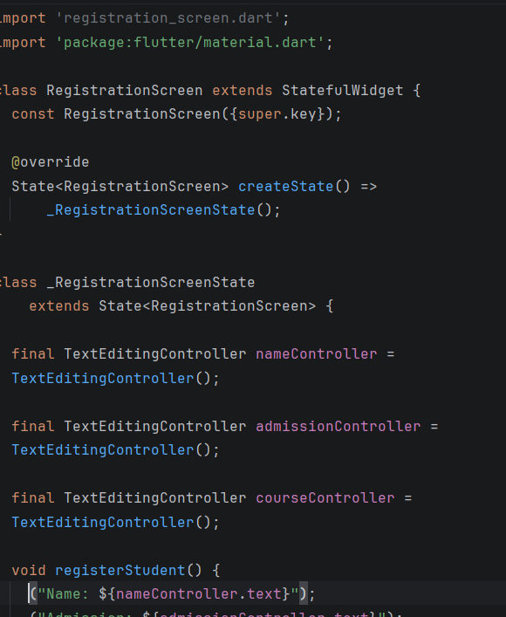
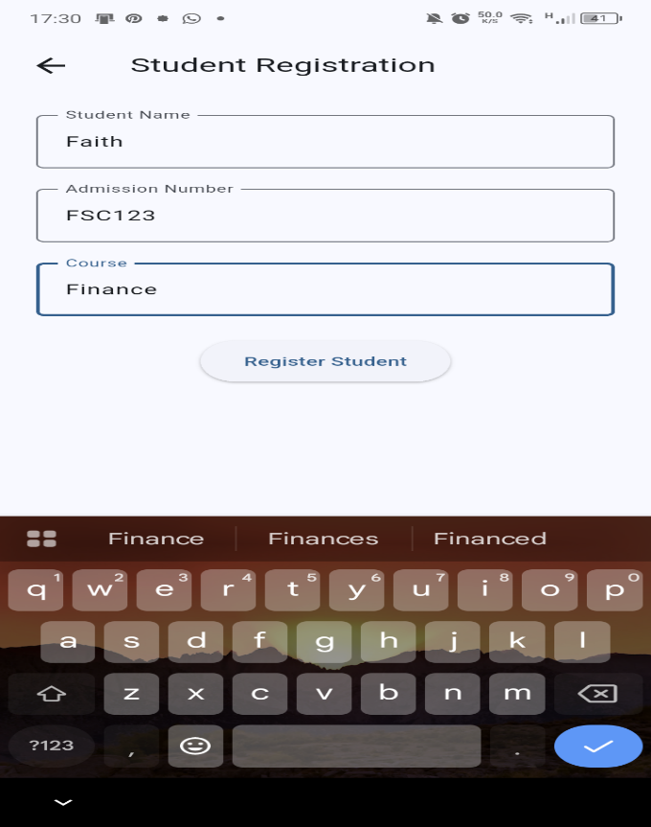
• Developed Dashboard Screen.
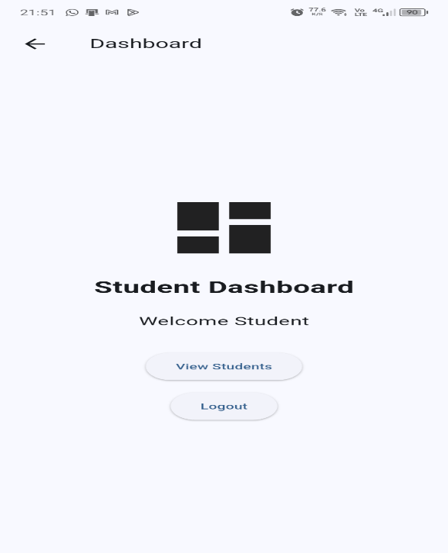

• Implemented buttons, text fields, images, menus, and navigation.
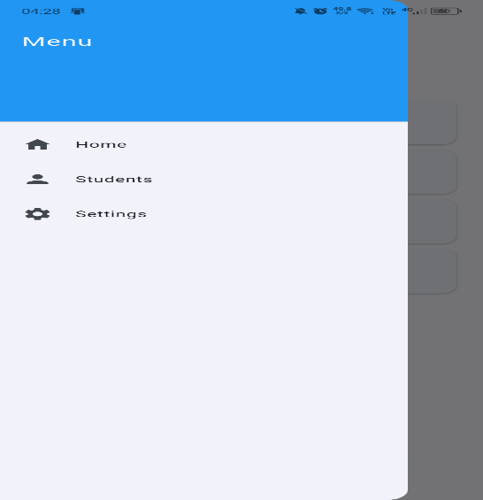
• Implemented screen navigation using Navigator.push().

Challenges Faced:
• Asset image loading errors.
• Bottom overflow error when keyboard appeared.
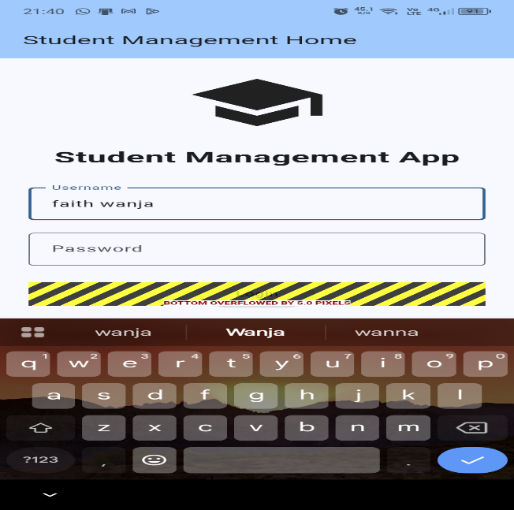

Solutions Implemented:
• Correctly configured assets and pubspec.yaml.
• Used scrolling widgets to prevent overflow.

Testing Evidence:
Successfully navigated between screens and entered student records.

Reflection:
I learned how Flutter widgets are used to create complete application interfaces.
Objective:
To implement local data storage using SQLite and persist student records.

Activities Completed:
• Added sqflite and path dependencies.
• Created database_helper.dart.
• Implemented database creation.
• Implemented insertStudent() method.
• Implemented getStudents() method.
• Displayed stored student records on the dashboard.

Challenges Faced:
• Dependency configuration and build errors.

Solutions Implemented:
• Installed required packages and rebuilt the project.

Testing Evidence:
Student records were successfully stored and retrieved from SQLite even after restarting the application.

Reflection:
I learned how SQLite provides persistent local storage in mobile applications.

SCREENSHOTS TAKEN
Flutter Project Creation Screen
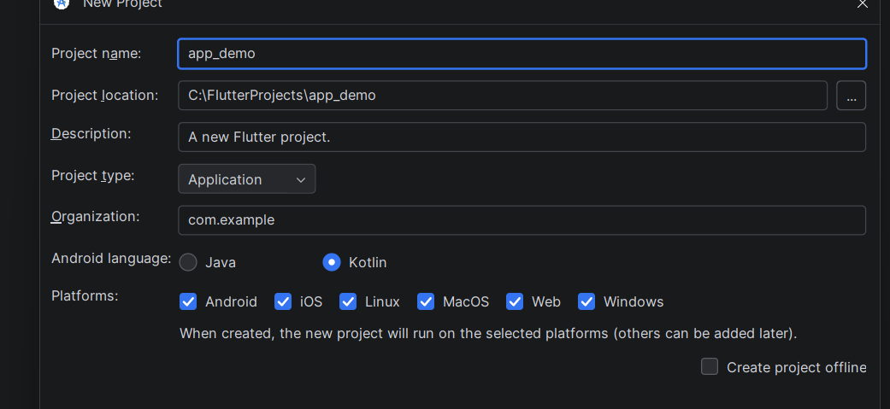
Project Structure and main.dart
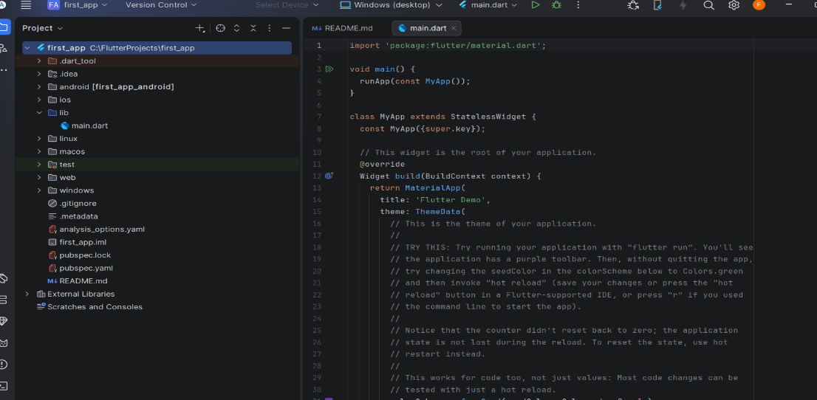
SQLite Dependencies in pubspec.yaml
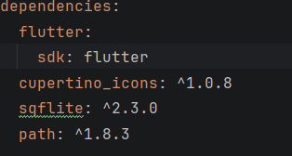
Database Helper Class
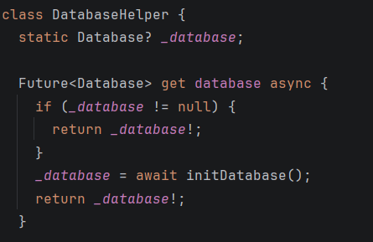
Dashboard Displaying SQLite Data
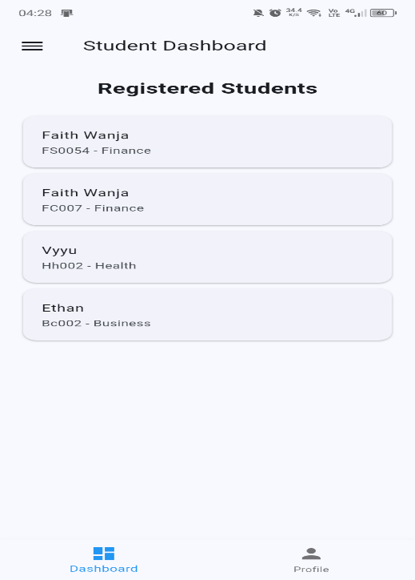
API Integration
Practical Activities Undertaken
- Added HTTP package dependency.
- Created API service class.
- Connected the application to a JSON API.
- Retrieved user data from the API.
- Displayed API data on the dashboard.

